
HOW TO DEBUG CODE IN MCUXPRESSO
Advanced Embedded Systems

Authors: Dr. Gilberto Ochoa Ruiz
Msc. Jorge German Perez Blanco
Contents
Introduction 3
The Debug Perspective 3
How to start to debug a program 4
Breakpoints and program flow control 5
Processor and peripheral registers 7
Local variables, global variables, and expressions 8
How to watch memory content 10

Introduction
Code debugging is a fundamental aspect of software development, playing a crucial role in identifying and rectifying errors within the code. These errors can encompass a range of issues, from basic syntax errors to more complex logical errors that result in unexpected behaviors. Debugging tools empower developers to systematically analyze their code, inspect variables, and comprehend the flow of execution, facilitating the precise location and correction of bugs. The impact of debugging extends to performance optimization. Bugs in code can negatively impact an application's performance, leading to bottlenecks. Debugging aids in identifying and optimizing problematic code sections, contributing to a faster and more efficient software experience for users.
Debugging is of paramount importance in the realm of embedded systems due to the unique challenges associated with these specialized computing environments. Embedded systems often operate in real-time scenarios, where precise and timely responses are critical for proper functionality. Debugging in this context ensures that the code meets stringent real-time constraints, allowing embedded systems to perform as expected within predefined time frames. Another significant factor in embedded systems is the constraint on resources such as memory, processing power, and energy. Debugging plays a pivotal role in optimizing code for efficient resource utilization. It helps identify and rectify issues like memory leaks, minimizes processing overhead, and ensures that the embedded system operates within its resource limitations. Embedded systems closely interact with hardware components, and debugging becomes essential for ensuring proper communication and synchronization between the software and hardware. Issues related to interrupts, I/O operations, and hardware interfaces can be identified and addressed through effective debugging processes. Unlike traditional computing environments, many embedded systems operate without direct user interfaces. Debugging becomes the primary means for diagnosing issues, as developers may lack visual feedback or traditional user interfaces to detect problems. Debugging tools, logs, and diagnostic information become critical for understanding and resolving issues in such scenarios.
Ultimately, debugging ensures that software meets user expectations and specifications. Users anticipate applications that work seamlessly without errors, and the diligent practice of debugging is instrumental in achieving this goal. In summary, debugging is an indispensable and ongoing process that directly shapes the creation of reliable, high-quality, and efficient software applications.

The Debug Perspective
This working mode adjusts the user interface to provide all relevant information associated with debugging. When we activate the Debug Perspective, the toolbar is modified, and sub windows are added to the interface, that allow us to view the processor registers, peripherals registers, local and global variables, evaluate expressions or view the memory contents. In the following image you can see the Debug Perspective.
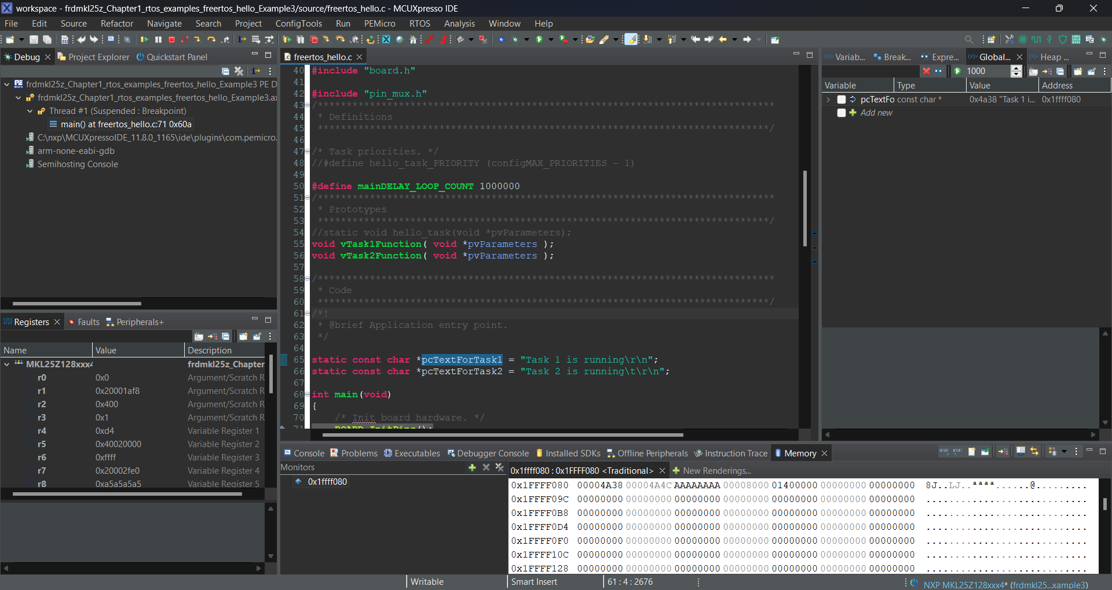
To access the Debug Perspective, you can click on the button located on the far right of the toolbar or also click on Window->Perspective->Open Perspective->Debug, note that the option will not appear if it is already in the Debug Perspective (see the following image).
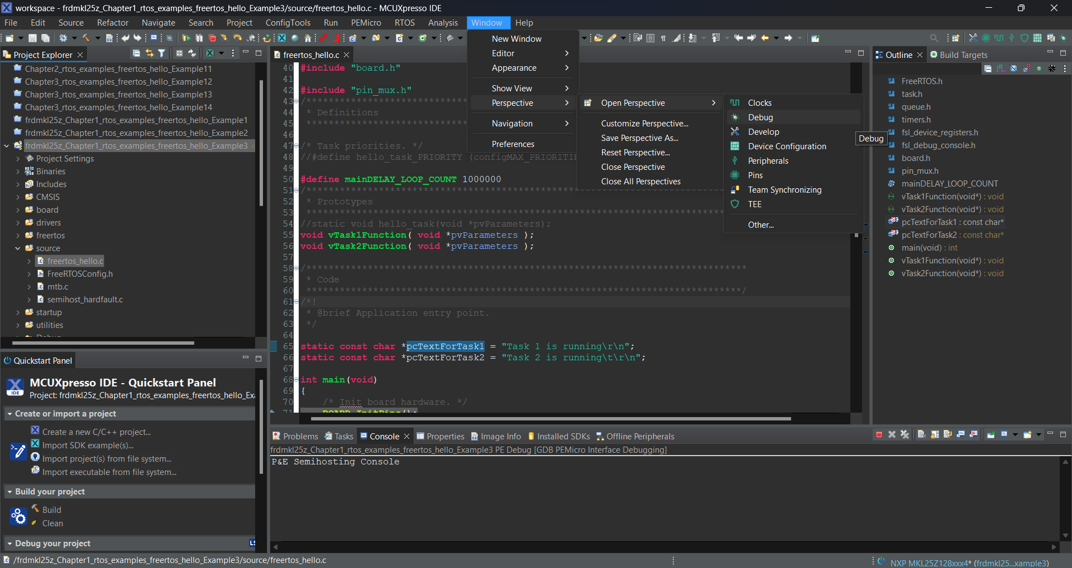

How to start to debug a program
If you want to debug the code that runs on your board you need to first make sure that the board is properly connected to your pc, all drivers are installed as shown in previous tutorials and that you have opened one of the projects available on your workspace for that board. Next you should click on Run->Debug As->3 PEMicro probes as shown in following image.
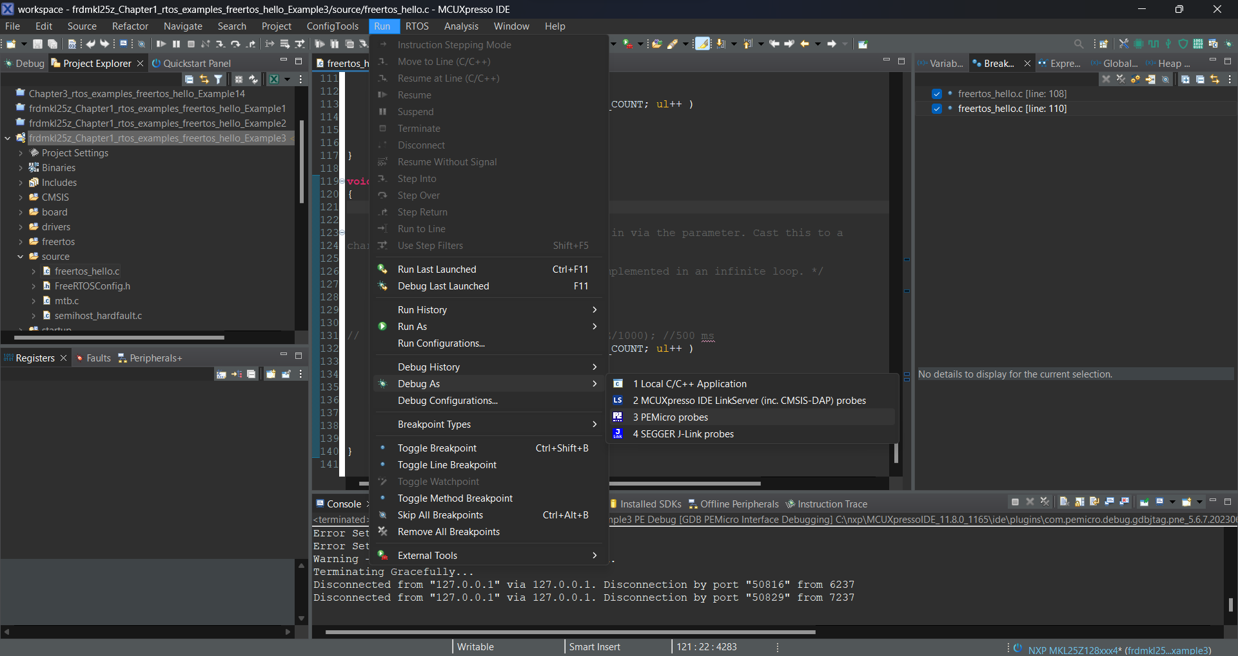
Once you start debugging by default the program will stop at the first line of executable code, this behavior can be changed but it’s recommended because it lets you start the execution when you are ready. You can check the actual line of execution at any time, it’s marked by a blue arrow at the left of the number of the line code, as seen in the following image.
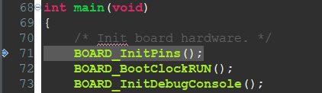

Breakpoints and program flow control
In programming, a breakpoint is a specified point in the code where the execution of a program will pause, allowing the developer to inspect the program's state, variables, and overall behavior at that particular moment. To add or remove a breakpoint simply double click on the number that corresponds to the line of code where you want the program to stop executing. Once the breakpoint is active you will see a little blue dot to the left of the number of the line of code, as seen in the following image for lines 108 and 110.
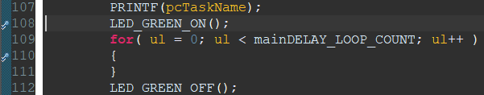
You can check all the breakpoints you have in your code at the proper sub window, at the right side of the screen in the Debug Perspective. In this sub window you can activate, deactivate or erase breakpoints.
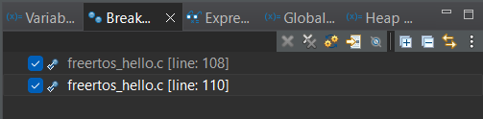
Keep in mind that the number of breakpoints in hardware systems sometimes are limited to the debugger in use, so try to keep active the number of breakpoints that you actually need. Not all lines of code have actual running code, sometimes they only contain comments or preprocessor directives, so you might get a warning message if you put the breakpoint in a place that cannot be use.
When you add a breakpoint, the program will halt its execution once it reaches that line of code. At that point you can check the content of variables, registers, and memory; that will be explained later. You can also control how the program will continue executing. You have several options here, you can resume, suspend, terminate, step into, step over among other options. You can access these options from the toolbar in Debug Perspective at the position shown in the following picture. The options for controlling the flow of program execution mentioned above are explained below.
The first option, mark with a yellow rectangle followed by a green triangle icon, is the resume execution. Once you hit that button the program will continue executing until it reaches the next breakpoint. Next option is suspend execution, its grayed out because the image was captured when the execution was already suspended, at a breakpoint. It’s represented by the icon with two rectangles (the color of the icon is yellow, when the option it’s not disabled). This option can be used to break the execution, bear in mind that if you hit the button when the program is running it will halt the execution at the line that was running. This is not a common use, we normally want that the execution halt at a precise line, not at a random one. Next option is terminate execution, the icon is the red square. Once you hit the button the program stops its execution and can only be resumed by restarting the application or the debug session. The next option is disconnect, the icon is represented by two red dots with an interrupted line connecting them. Once you hit it, the program continues its execution but you no longer have control of the flow of program, neither the program will stop at breakpoints, not very useful for debugging purposes, only at very specific situations. Next options are step into, and step over, marked by a squared yellow arrow and a rounded yellow arrow respectively. These options are related to breakpoints on a line of code that contains a function call. When you hit step into in a line of code that contains a function call, it will enter the function and halt at the first line of code inside that function. Then you can check what happens inside, run step by step, watch local variables etc. If you hit step over in a line of code that contains a function call, it will execute all the code inside the function and the execution will be halted at the line right before the function call. You can check the result of the execution of the function but not all the steps that happened inside of it. The final option is step return, this option is used when you have previously hit the step into option and suddenly want to return to the line of code that is next to the function call.

Processor and peripheral registers
On a sub window located at the left side of the screen in the Debug Perspective you can check the processor and peripheral registers, by activating the proper sub window you can see the values of the registers as shown in the following pictures.
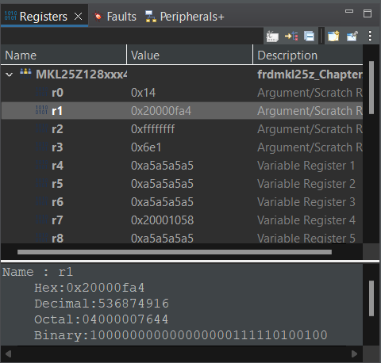
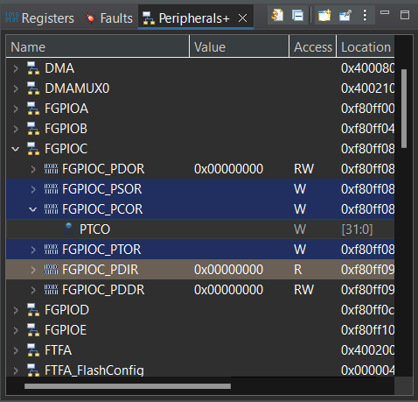
In the case of the processor, the information is shown in a table with the name of the register, the actual value, and a description of it. In the area at the bottom you can check several representations of the value of the selected register.
For the peripheral registers, the information is shown in a tree view, that organizes all the registers in their respective peripheral. You can also check its value, the access permission and the address of the register.

Local variables, global variables, and expressions
In the same sub window that you can check the breakpoints, located at the at the right side of the screen in the Debug Perspective, by activating the appropriate tab, you can check the local variables, global variables and evaluate expressions, as can be seen in the following pictures.
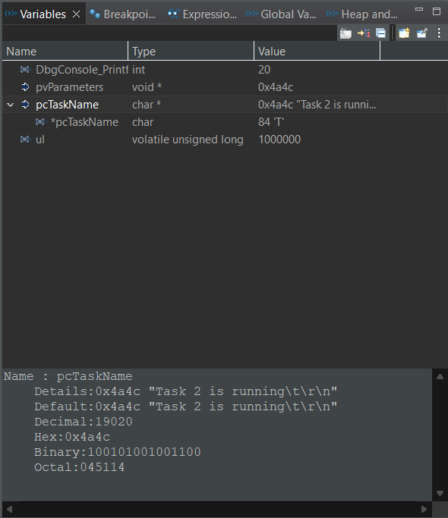
In this window you can check all local variables, in a table view you can check their name, type, and value. At the bottom you can see a more detailed view of the variable selected, and some other ways to represent its content.
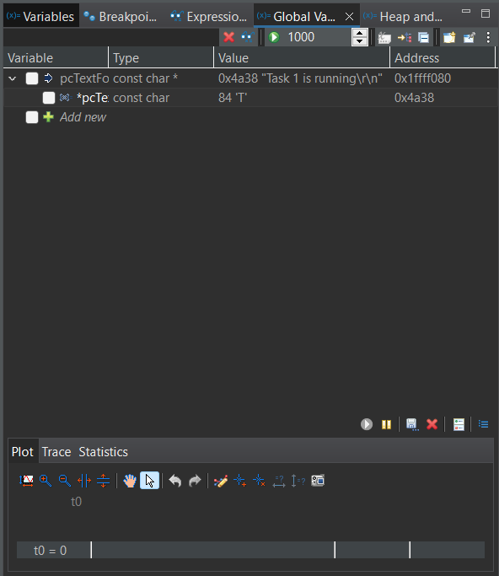
In this window you can check all global variables, in a table view you can check their name, type, value and memory address. At the bottom you have some options to plot the variable over time, trace and calculate statics.
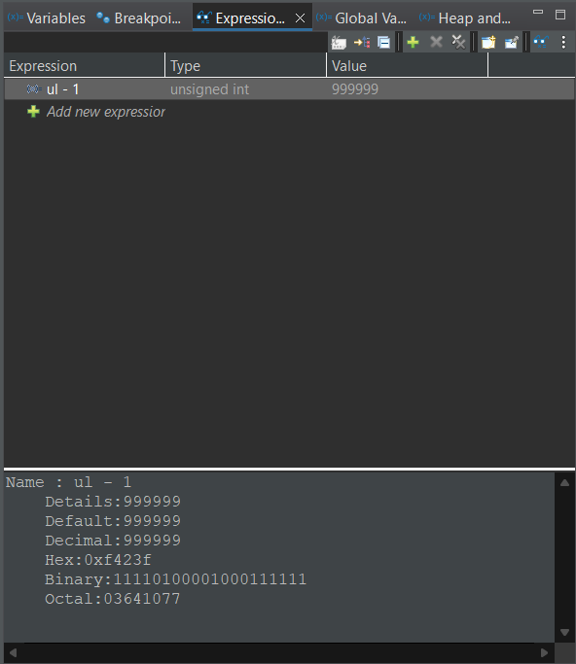
In the expressions windows you can add custom expressions related to the variables, and evaluate the result, as shown with variable ul. The information is also shown in a table view with same parameters as in the case of the local variables, and with also have a detailed view at the bottom of the window.

How to watch memory content
Sometimes we need to check a particular address of memory to see its content, to check for memory corruption, make some pointer analysis, detect initialization issues or memory leaks. This is possible through the Memory Window in Debug Perspective, located in one of the tabs, at the bottom of the screen. This window is shown in the following picture. You can add a new location to add through the green plus icon shown in the picture, and then introducing the address.
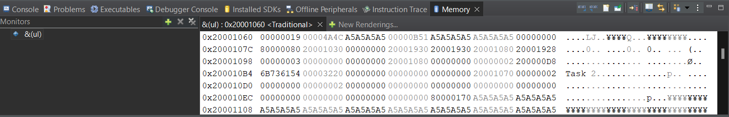
In the right side of the window, you can see the memory content of the location, you can format the view to your needs if you right click on the memory area.
You can also right click on any of the variables that are visualized through the local and global variable windows, and select the option View Memory, this will automatically add the variable to the monitors in the Memory Window.

